Restaurant Mini-project:

1. Run npm i -g json-server from command prompt
2. Download food.json and images folder and keep it within the workspace insdie a folder food
3. From within food folder run command :   
   json-server –watch food.json

Screen looks as follows:

MainComponent – is child of App which has dropdown and cart.

ProductListComponent is child of MainComponent

ProductComponent is child of ProductList

ProductListComponent

AppComponent

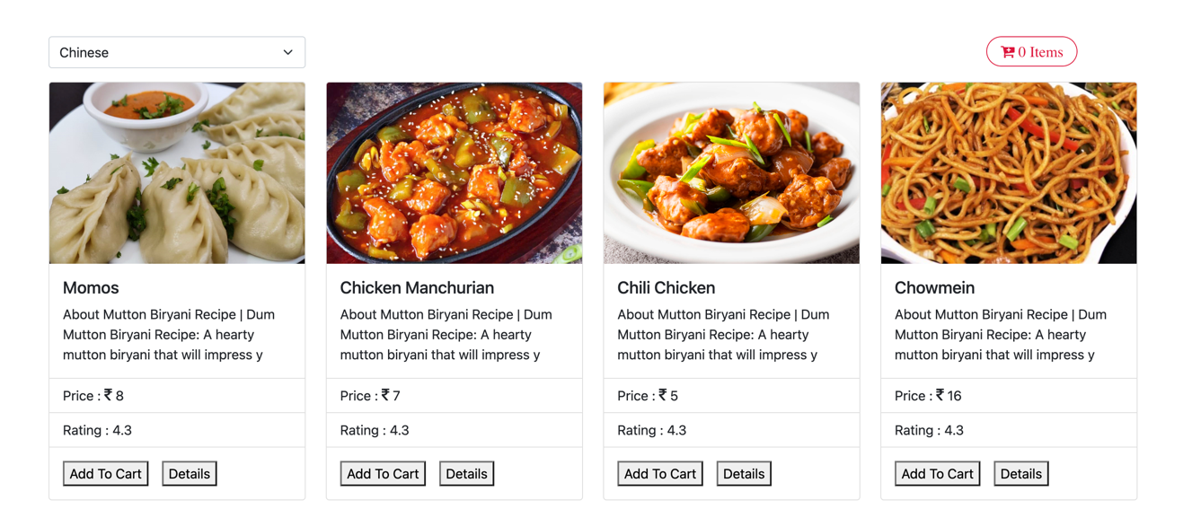

Clicking on dropdown displays different categories

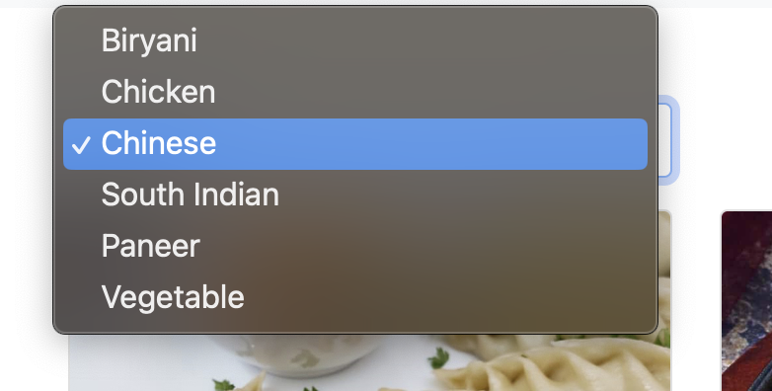

Selecting category changes images

